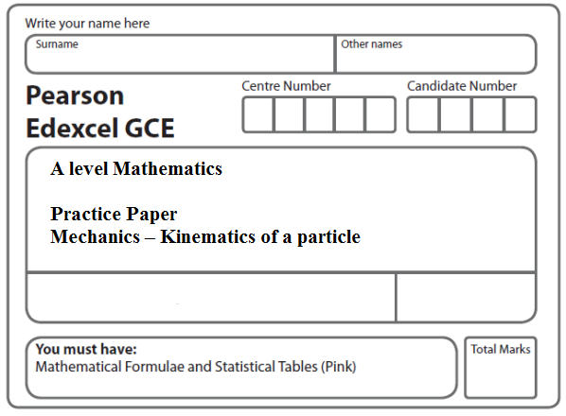
Instructions
- Use black ink or ball-point pen.
- If pencil is used for diagrams/sketches/graphs it must be dark (HB or B).
- Fill in the boxes at the top of this page with your name, centre number and candidate number.
- Answer all the questions and ensure that your answers to parts of questions are clearly labelled.
- Answer the questions in the spaces provided – there may be more space than you need.
- You should show sufficient working to make your methods clear. Answers without working may not gain full credit.
- Inexact answers should be given to three significant figures unless otherwise stated.
Information
- A booklet ‘Mathematical Formulae and Statistical Tables’ is provided.
- There are 12 questions in this question paper. The total mark for this paper is 154.
- The marks for each question are shown in brackets – use this as a guide as to how much time to spend on each question.
- Calculators must not be used for questions marked with a * sign.
Advice
• Read each question carefully before you start to answer it.
• Try to answer every question.
• Check your answers if you have time at the end.
• If you change your mind about an answer, cross it out and put your new answer and any working underneath.
1. [In this question i and j are perpendicular unit vectors in a horizontal plane.]
A particle P moves in such a way that its velocity v m s^{–1} at time t seconds is given by

v = (3t ² – 1)i + (4t – t ²)j.

(a) Find the magnitude of the acceleration of P when t = 1.
(5)
Given that, when t = 0, the position vector of P is i metres,

(b) find the position vector of P when t = 3.
(5)
(Total 10 marks)
___________________________________________________________________________

2. At time t seconds, where t ≥ 0, a particle P is moving on a horizontal plane with acceleration [(3t² – 4t)i + (6t – 5)j] m s^{–2}.
When t = 3 the velocity of P is (11i + 10j) m s^{–1}.

Find

(a) the velocity of P at time t seconds,
(5)
(b) the speed of P when it is moving parallel to the vector i.
(4)
(Total 9 marks)
___________________________________________________________________________

3. A particle P is moving in a plane. At time t seconds, P is moving with velocity v m s⁻¹, where v = 2ti − 3t² j.
Find

(a) the speed of P when t = 4,
(2)
(b) the acceleration of P when t = 4.
(3)

Given that P is at the point with position vector (−4i + j) m when t = 1,

(c) find the position vector of P when t = 4.
(5)

(Total 10 marks)
___________________________________________________________________________

4. Two particles P and Q, of masses 2m and m respectively, are on a smooth horizontal table. Particle Q is at rest and particle P collides directly with it when moving with speed u. After the collision the total kinetic energy of the two particles is . Find

(a) the speed of Q immediately after the collision,
(10)
(b) the coefficient of restitution between the particles.
(3)
(Total 13 marks)
___________________________________________________________________________

5.
Figure 1

A small ball is projected with speed 14 m s^{–1} from a point A on horizontal ground. The angle of projection is α above the horizontal. A horizontal platform is at height h metres above the ground. The ball moves freely under gravity until it hits the platform at the point B, as shown in Figure 1. The speed of the ball immediately before it hits the platform at B is 10 m s^{–1}.

(a) Find the value of h.
(4)

Given that sin α = 0.85,

(b) find the horizontal distance from A to B.
(8)
(Total 12 marks)
___________________________________________________________________________
6.

Figure 2

A ball is thrown from a point O, which is 6 m above horizontal ground. The ball is projected with speed u m s⁻¹ at an angle θ above the horizontal. There is a thin vertical post which is 4 m high and 8 m horizontally away from the vertical through O, as shown in Figure 2. The ball passes just above the top of the post 2 s after projection. The ball is modelled as a particle.

(a) Show that tan θ = 2.2.
(5)
(b) Find the value of u.
(2)

The ball hits the ground T seconds after projection.

(c) Find the value of T.
(3)

Immediately before the ball hits the ground the direction of motion of the ball makes an angle α with the horizontal.

(d) Find α.
(5)
(Total 15 marks)
___________________________________________________________________________
7. [In this question, the unit vectors i and j are in a vertical plane, i being horizontal and j being vertically upwards.]

Figure 3

At time t = 0, a particle P is projected from the point A which has position vector 10j metres with respect to a fixed origin O at ground level. The ground is horizontal. The velocity of projection of P is (3i + 5j) m s^{–1}, as shown in Figure 3. The particle moves freely under gravity and reaches the ground after T seconds.

(a) For 0 ≤ t ≤ T, show that, with respect to O, the position vector, r metres, of P at time t seconds is given by

r = 3ti + (10 + 5t – 4.9t²)j
(3)
(b) Find the value of T.
(3)
(c) Find the velocity of P at time t seconds (0 ≤ t ≤ T ).
(2)

When P is at the point B, the direction of motion of P is 45° below the horizontal.

(d) Find the time taken for P to move from A to B.
(2)
(e) Find the speed of P as it passes through B.
(2)
(Total 12 marks)
___________________________________________________________________________

8. [In this question, the unit vectors i and j are horizontal and vertical respectively.]

Figure 4

The point O is a fixed point on a horizontal plane. A ball is projected from O with velocity (6i + 12j) m s⁻¹, and passes through the point A at time t seconds after projection. The point B is on the horizontal plane vertically below A, as shown in Figure 4. It is given that OB = 2AB.

Find

(a) the value of t,
(7)
(b) the speed, V m s⁻¹, of the ball at the instant when it passes through A.
(5)

At another point C on the path the speed of the ball is also V m s⁻¹.

(c) Find the time taken for the ball to travel from O to C.
(3)
(Total 15 marks)
___________________________________________________________________________

9.
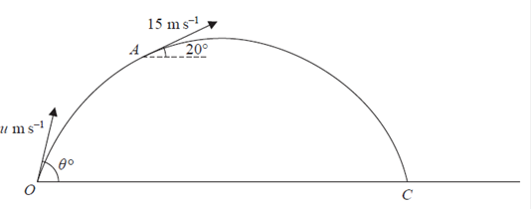

Figure 5

At time t = 0, a particle is projected from a fixed point O on horizontal ground with speed u m s^{–1} at an angle θ ° to the horizontal. The particle moves freely under gravity and passes through the point A when t = 4 s. As it passes through A, the particle is moving upwards at 20° to the horizontal with speed 15 m s^{–1}, as shown in Figure 5.

(a) Find the value of u and the value of θ.
(7)

At the point B on its path the particle is moving downwards at 20° to the horizontal with speed 15 m s^{–1}.

(b) Find the time taken for the particle to move from A to B.
(2)

The particle reaches the ground at the point C.

(c) Find the distance OC.
(3)
(Total 12 marks)
___________________________________________________________________________

10.
Figure 6

A small ball is projected from a fixed point O so as to hit a target T which is at a horizontal distance 9a from O and at a height 6a above the level of O. The ball is projected with speed √(27ag) at an angle θ to the horizontal, as shown in Figure 6. The ball is modelled as a particle moving freely under gravity.

(a) Show that tan² θ – 6 tan θ + 5 = 0.
(7)

The two possible angles of projection are θ₁ and θ₂, where θ₁ > θ₂.

(b) Find tan θ₁ and tan θ₂.
(3)

The particle is projected at the larger angle θ₁.

(c) Show that the time of flight from O to T is .
(3)
(d) Find the speed of the particle immediately before it hits T.
(3)
(Total 16 marks)
___________________________________________________________________________

11.

Figure 7

A small stone is projected from a point O at the top of a vertical cliff OA. The point O is 52.5 m above the sea. The stone rises to a maximum height of 10 m above the level of O before hitting the sea at the point B, where AB = 50 m, as shown in Figure 7. The stone is modelled as a particle moving freely under gravity.

(a) Show that the vertical component of the velocity of projection of the stone is 14 m s^{–1}.
(3)
(b) Find the speed of projection.
(9)
(c) Find the time after projection when the stone is moving parallel to OB.
(5)
(Total 17 marks)
___________________________________________________________________________
12. A particle is projected from a point O with speed u at an angle of elevation α above the horizontal and moves freely under gravity. When the particle has moved a horizontal distance x, its height above O is y.

(a) Show that
y = x tan α – .
(4)

A girl throws a ball from a point A at the top of a cliff. The point A is 8 m above a horizontal beach. The ball is projected with speed 7 m s⁻¹ at an angle of elevation of 45°. By modelling the ball as a particle moving freely under gravity,

(b) find the horizontal distance of the ball from A when the ball is 1 m above the beach.
(5)

A boy is standing on the beach at the point B vertically below A. He starts to run in a straight line with speed v m s⁻¹, leaving B 0.4 seconds after the ball is thrown.

He catches the ball when it is 1 m above the beach.

(c) Find the value of v.
(4)
(Total 13 marks)

TOTAL FOR PAPER: 154 MARKS

