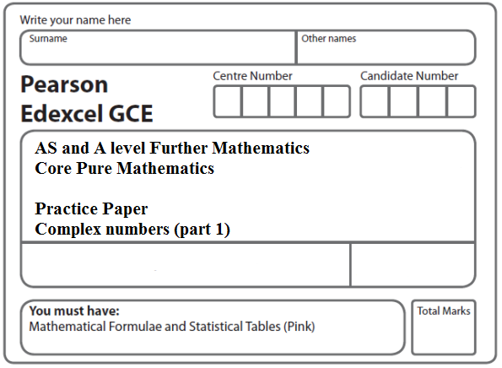

Instructions
- Use black ink or ball-point pen.
- If pencil is used for diagrams/sketches/graphs it must be dark (HB or B).
- Fill in the boxes at the top of this page with your name, centre number and candidate number.
- Answer all the questions and ensure that your answers to parts of questions are clearly labelled.
- Answer the questions in the spaces provided – there may be more space than you need.
- You should show sufficient working to make your methods clear. Answers without working may not gain full credit.
- Inexact answers should be given to three significant figures unless otherwise stated.
Information
- A booklet ‘Mathematical Formulae and Statistical Tables’ is provided.
- There are 15 questions in this question paper. The total mark for this paper is 100.
- The marks for each question are shown in brackets – use this as a guide as to how much time to spend on each question.
- Calculators must not be used for questions marked with a * sign.
Advice
• Read each question carefully before you start to answer it.
• Try to answer every question.
• Check your answers if you have time at the end.
• If you change your mind about an answer, cross it out and put your new answer and any working underneath.
1. f(x) = 9x³ – 33x² – 55x – 25.
Given that x = 5 is a solution of the equation f(x) = 0, use an algebraic method to solve f(x) = 0 completely.
(Total 5 marks)
___________________________________________________________________________

2. f(x) = 2x³ – 6x² – 7x − 4.
(a) Show that f(4) = 0.
(1)
(b) Use algebra to solve f(x) = 0 completely.
(4)
(Total 5 marks)
___________________________________________________________________________

3. The roots of the equation
2z³ – 3z² + 8z + 5 = 0
are z₁, z₂ and z₃.
Given that z₁ = 1 + 2i, find z₂ and z₃.
(5)
(Total 5 marks)
___________________________________________________________________________

4. The complex numbers z₁ and z₂ are given by
z₁ = p + 2i and z₂ = 1 – 2i
where p is an integer.
(a) Find in the form a + bi where a and b are real. Give your answer in its simplest form in terms of p.
(4)
Given that ,
(b) find the possible values of p.
(4)
(Total 8 marks)
___________________________________________________________________________

5. The complex numbers z and w are given by

z = 8 + 3i, w = –2i

Express in the form a + bi, where a and b are real constants,

(a) z – w,
(1)
(b) zw.
(2)
(Total 3 marks)
___________________________________________________________________________
6. Given that $z_{1}$ =1 − i,
(a) find arg ($z_{1}$).
(2)
Given also that $z_{2}$ = 3 + 4i, find, in the form a + ib, a, b ∈ ℝ,
(b) $z_{1}$$z_{2}$,
(2)
(c) $\frac{z_{2}}{z_{1}}$.
(3)
In part (b) and part (c) you must show all your working clearly.
(Total 7 marks)
___________________________________________________________________________

7. z = 5 – 3i, w = 2 + 2i

Express in the form a + bi, where a and b are real constants,
(a) z²,
(2)
(b) $\frac{z}{w}$.
(3)
(Total 5 marks)
___________________________________________________________________________

8. $z_{1}$ = − 2 + i
(a) Find the modulus of $z_{1}$.
(1)
(b) Find, in radians, the argument of $z_{1}$, giving your answer to 2 decimal places.
(2)
The solutions to the quadratic equation
z² − 10z + 28 = 0
are $z_{2}$ and $z_{3}$.
(c) Find $z_{2}$ and $z_{3}$, giving your answers in the form p ± i√q, where p and q are integers.
(3)
(d) Show, on an Argand diagram, the points representing your complex numbers $z_{1}$, $z_{2}$ and $z_{3}$ .
(2)
(Total 8 marks)
___________________________________________________________________________

9. z = $\frac{\text{50}}{3+4i}$.
Find, in the form a + ib where a, b ∈ ℝ,

(a) z,
(2)
(b) z².
(2)
Find
(c) ⏐z⏐,
(2)
(d) arg z², giving your answer in degrees to 1 decimal place.
(2)
(Total 8 marks)
___________________________________________________________________________
10. Given that 2 and 1 – 5i are roots of the equation

x³ + px² + 30x + q = 0, p, q ∈ ℝ

(a) write down the third root of the equation.
(1)
(b) Find the value of p and the value of q.
(5)
(c) Show the three roots of this equation on a single Argand diagram.
(2)
Total 8 marks)
___________________________________________________________________________

11. Given that x = is a root of the equation
2x³ – 9x² + kx – 13 = 0, k ∈ ℝ
find
(a) the value of k,
(3)
(b) the other 2 roots of the equation.
(4)
(Total 7 marks)
___________________________________________________________________________

12. (i) The complex number w is given by
where p is a real constant.
(a) Express w in the form a + bi, where a and b are real constants.
Give your answer in its simplest form in terms of p.
(3)
Given that arg w =
(b) find the value of p.
(2)
(ii) The complex number z is given by
z = (1 – 𝜆 i)(4 + 3i)
where 𝜆 is a real constant.
Given that
|z| = 45
find the possible values of 𝜆.
Give your answers as exact values in their simplest form.
(3)
(Total 8 marks)
___________________________________________________________________________

13. $z_{1}$ = 3i and $z_{2}$ = $\frac{6}{1+i√3}$.

(a) Express $z_{2}$ in the form a + ib, where a and b are real numbers.
(2)

(b) Find the modulus and the argument of $z_{2}$, giving the argument in radians in terms of π.
(4)

(c) Show the three points representing $z_{1}$, $z_{2}$ and ($z_{1}$ + $z_{2}$) respectively, on a single Argand diagram.
(2)
(Total 8 marks)
___________________________________________________________________________
14. The complex number z is given by
where p is an integer.

(a) Express z in the form a + bi where a and b are real. Give your answer in its simplest form in terms of p.
(4)
(b) Given that arg(z) = θ, where tan θ = 1 find the possible values of p.
(5)
(Total 9 marks)
___________________________________________________________________________

15. f(x) = (4x² +9)(x² – 2x + 5)

(a) Find the four roots of f(x) = 0.
(4)
(b) Show the four roots of f(x) = 0 on a single Argand diagram.
(2)
(Total 6 marks)

TOTAL FOR PAPER: 100 MARKS

