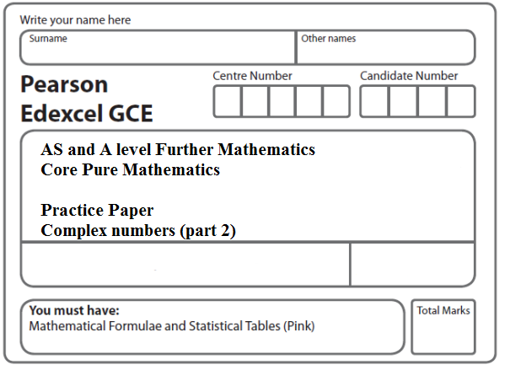

Instructions
- Use black ink or ball-point pen.
- If pencil is used for diagrams/sketches/graphs it must be dark (HB or B).
- Fill in the boxes at the top of this page with your name, centre number and candidate number.
- Answer all the questions and ensure that your answers to parts of questions are clearly labelled.
- Answer the questions in the spaces provided – there may be more space than you need.
- You should show sufficient working to make your methods clear. Answers without working may not gain full credit.
- Inexact answers should be given to three significant figures unless otherwise stated.
Information
- A booklet ‘Mathematical Formulae and Statistical Tables’ is provided.
- There are 11 questions in this question paper. The total mark for this paper is 100.
- The marks for each question are shown in brackets – use this as a guide as to how much time to spend on each question.
- Calculators must not be used for questions marked with a * sign.
Advice
• Read each question carefully before you start to answer it.
• Try to answer every question.
• Check your answers if you have time at the end.
• If you change your mind about an answer, cross it out and put your new answer and any working underneath.
1. z = $\frac{4}{1+i}$.
Find, in the form a + ib where a, b ∈ ℝ,

(a) z,
(2)
(b) z².
(2)

Given that z is a complex root of the quadratic equation x² + px + q = 0, where p and q are real integers,

(c) find the value of p and the value of q.
(3)
(Total 7 marks)
___________________________________________________________________________

2. f(x) = (4x² + 9)(x² − 6x + 34).

(a) Find the four roots of f (x) = 0.
Give your answers in the form x = p + iq , where p and q are real.
(5)
(b) Show these four roots on a single Argand diagram.
(2)
(Total 7 marks)
___________________________________________________________________________

3. The roots of the equation
z³ − 8z² + 22z − 20 = 0
are $z_{1}$, $z_{2}$ and $z_{3}$ .

(a) Given that $z_{1}$ = 3 + i, find $z_{2}$ and $z_{3}$.
(4)
(b) Show, on a single Argand diagram, the points representing $z_{1}$, $z_{2}$ and $z_{3}$.
(2)
(Total 6 marks)
___________________________________________________________________________

4. Given that 4 and 2i – 3 are roots of the equation
x³ + ax² + bx – 52 = 0
where a and b are real constants,
(a) write down the third root of the equation,
(1)
(b) find the value of a and the value of b.
(5)
(Total 6 marks)
___________________________________________________________________________

5. Given that z = x + iy, find the value of x and the value of y such that
z + 3iz* = −1 + 13i
where z* is the complex conjugate of z.
(Total 7 marks)
___________________________________________________________________________

6. A complex number z is given by z = a + 2i,
where a is a non-zero real number.

(a) Find z² + 2z in the form x + iy where x and y are real expressions in terms of a.
(4)

Given that z² + 2z is real,

(b) find the value of a.
(1)

Using this value for a,

(c) find the values of the modulus and argument of z, giving the argument in radians, and giving your answers to 3 significant figures.
(3)
(d) Show the points P, Q and R, representing the complex numbers z, z² and z² + 2z respectively, on a single Argand diagram with origin O.
(3)
(e) Describe fully the geometrical relationship between the line segments OP and QR.
(2)
(Total 13 marks)
___________________________________________________________________________

7. z₁ = 2 + 3i, z₂ = 3 + 2i, z₃ = a + bi, a, b ∈ ℝ
(a) Find the exact value of |z₁ + z₂|.
(2)
Given that w = ,
(b) find w in terms of a and b, giving your answer in the form x + iy, x, y ∈ ℝ
(4)
Given also that w = ,
(c) find the value of a and the value of b,
(3)
(d) find arg w, giving your answer in radians to 3 decimal places.
(2)
(Total 11 marks)
___________________________________________________________________________
8. z = 2 − i√3.
(a) Calculate arg z, giving your answer in radians to 2 decimal places.
(2)
Use algebra to express
(b) z + z² in the form a + bi√3, where a and b are integers,
(3)
(c) $\frac{z+7}{z−1}$ in the form c + di√3, where c and d are integers.
(4)
Given that w = λ – 3i,
where λ is a real constant, and arg (4 – 5i + 3w) = –$\frac{π}{2}$,
(d) find the value of λ.
(2)
(Total 11 marks)
___________________________________________________________________________

9. z = – 24 – 7i
(a) Show z on an Argand diagram.
(1)
(b) Calculate arg z, giving your answer in radians to 2 decimal places.
(2)
It is given that w = a + bi, a ∈ ℝ, b ∈ ℝ.
Given also that ⎜w⎜ = 4 and arg w = $\frac{5π}{6}$,
(c) find the values of a and b,
(3)
(d) find the value of ⎜zw⎜.
(3)
(Total 9 marks)
___________________________________________________________________________
10. The point P represents a complex number z on an Argand diagram such that
⏐z − 6i⏐= 2⏐z − 3⏐.
(a) Show that, as z varies, the locus of P is a circle, stating the radius and the coordinates of the centre of this circle.
(6)
The point Q represents a complex number z on an Argand diagram such that
arg (z − 6) = $−\frac{3π}{4}$.
(b) Sketch, on the same Argand diagram, the locus of P and the locus of Q as z varies.
(4)
(c) Find the complex number for which both ⏐z − 6i⏐= 2⏐z − 3⏐ and arg (z − 6) = $−\frac{3π}{4}$.
(4)
(Total 14 marks)
___________________________________________________________________________

11. The complex number w is given by
w = 10 – 5i
(a) Find .
(1)
(b) Find arg w, giving your answer in radians to 2 decimal places
(2)
The complex numbers z and w satisfy the equation
(2 + i)(z + 3i) = w
(c) Use algebra to find z, giving your answer in the form a + bi,
where a and b are real numbers.
(4)
Given that
arg(λ + 9i + w) =
where λ is a real constant,
(d) find the value of λ.
(2)
(Total 9 marks)

TOTAL FOR PAPER: 100 MARKS

