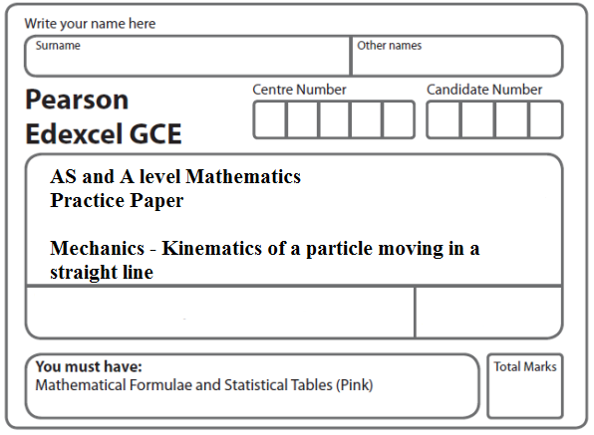
Instructions
- Use black ink or ball-point pen.
- If pencil is used for diagrams/sketches/graphs it must be dark (HB or B).
- Fill in the boxes at the top of this page with your name, centre number and candidate number.
- Answer all the questions and ensure that your answers to parts of questions are clearly labelled.
- Answer the questions in the spaces provided – there may be more space than you need.
- You should show sufficient working to make your methods clear. Answers without working may not gain full credit.
- Inexact answers should be given to three significant figures unless otherwise stated.
Information
- A booklet ‘Mathematical Formulae and Statistical Tables’ is provided.
- There are 10 questions in this question paper. The total mark for this paper is 100.
- The marks for each question are shown in brackets – use this as a guide as to how much time to spend on each question.
Advice
• Read each question carefully before you start to answer it.
• Try to answer every question.
• Check your answers if you have time at the end.
• If you change your mind about an answer, cross it out and put your new answer and any working underneath.
1. At time t = 0 a ball is projected vertically upwards from a point O and rises to a maximum height of 40 m above O. The ball is modelled as a particle moving freely under gravity.
(a) Show that the speed of projection is 28 m s^{–1}.
(3)
(b) Find the times, in seconds, when the ball is 33.6 m above O.
(5)
(Total 8 marks)
___________________________________________________________________________

2. A small stone is projected vertically upwards from a point O with a speed of 19.6 m s^{–1}. Modelling the stone as a particle moving freely under gravity,
(a) find the greatest height above O reached by the stone,
(2)
(b) find the length of time for which the stone is more than 14.7 m above O.
(5)
(Total 7 marks)
___________________________________________________________________________

3. At time t = 0, a particle is projected vertically upwards with speed u from a point A. The particle moves freely under gravity. At time T the particle is at its maximum height H
above A.

(a) Find T in terms of u and g.
(2)
(b) Show that .
(2)

The point A is at a height 3H above the ground.

(c) Find, in terms of T, the total time from the instant of projection to the instant when the particle hits the ground.
(4)
(Total 8 marks)
___________________________________________________________________________

4. A car starts from rest and moves with constant acceleration along a straight horizontal road. The car reaches a speed of V m s^{–1} in 20 seconds. It moves at constant speed V m s^{–1} for the next 30 seconds, then moves with constant deceleration m s^{–2} until it has speed 8 m s^{–1}. It moves at speed 8 m s^{–1} for the next 15 seconds and then moves with constant deceleration
m s^{–2} until it comes to rest.

(a) Sketch a speed-time graph for this journey.
(3)

In the first 20 seconds of this journey the car travels 140 m.

Find

(b) the value of V,
(2)
(c) the total time for this journey,
(4)
(d) the total distance travelled by the car.
(4)

(Total 13 marks)
___________________________________________________________________________

5. At time t = 0, two balls A and B are projected vertically upwards. The ball A is projected vertically upwards with speed 2 m s^{–1} from a point 50 m above the horizontal ground. The ball B is projected vertically upwards from the ground with speed 20 m s^{–1}. At time t = T seconds, the two balls are at the same vertical height, h metres, above the ground. The balls are modelled as particles moving freely under gravity.

Find

(a) the value of T,
(5)
(b) the value of h.
(2)
(Total 7 marks)
___________________________________________________________________________
6. A lorry is moving along a straight horizontal road with constant acceleration. The lorry passes a point A with speed u m s^{–1}, (u < 34), and 10 seconds later passes a point B with speed 34 m s^{–1}. Given that AB = 240 m, find

(a) the value of u,
(3)
(b) the time taken for the lorry to move from A to the mid-point of AB.
(6)
(Total 9 marks)
___________________________________________________________________________
7. Two trains M and N are moving in the same direction along parallel straight horizontal tracks. At time t = 0, M overtakes N whilst they are travelling with speeds 40 m s^{–1} and 30 m s^{–1} respectively. Train M overtakes train N as they pass a point X at the side of the tracks.

After overtaking N, train M maintains its speed of 40 m s^{–1} for T seconds and then decelerates uniformly, coming to rest next to a point Y at the side of the tracks.

After being overtaken, train N maintains its speed of 30 m s^{–1} for 25 s and then decelerates uniformly, also coming to rest next to the point Y.

The times taken by the trains to travel between X and Y are the same.

(a) Sketch, on the same diagram, the speed-time graphs for the motions of the two trains between X and Y.
(4)
Given that XY = 975 m,

(b) find the value of T.
(8)
(Total 12 marks)
___________________________________________________________________________

8. A car is moving on a straight horizontal road. At time t = 0, the car is moving with speed 20 m s^{–1} and is at the point A. The car maintains the speed of 20 m s^{–1} for 25 s. The car then moves with constant deceleration 0.4 m s^{–2}, reducing its speed from 20 m s^{–1} to 8 m s^{–1}. The car then moves with constant speed 8 m s^{–1} for 60 s. The car then moves with constant acceleration until it is moving with speed 20 m s^{–1} at the point B.

(a) Sketch a speed-time graph to represent the motion of the car from A to B.
(3)
(b) Find the time for which the car is decelerating.
(2)

Given that the distance from A to B is 1960 m,

(c) find the time taken for the car to move from A to B.
(8)
(Total 13 marks)
___________________________________________________________________________

9. A girl runs a 400 m race in a time of 84 s. In a model of this race, it is assumed that, starting from rest, she moves with constant acceleration for 4 s, reaching a speed of 5 m s^{–1}. She maintains this speed for 60 s and then moves with constant deceleration for 20 s, crossing the finishing line with a speed of V m s^{–1}.
(a) Sketch a speed-time graph for the motion of the girl during the whole race.
(2)
(b) Find the distance run by the girl in the first 64 s of the race.
(3)
(c) Find the value of V.
(5)
(d) Find the deceleration of the girl in the final 20 s of her race.
(2)
(Total 12 marks)
___________________________________________________________________________

10. A car is travelling along a straight horizontal road. The car takes 120 s to travel between two sets of traffic lights which are 2145 m apart. The car starts from rest at the first set of traffic lights and moves with constant acceleration for 30 s until its speed is 22 m s^{–1}. The car maintains this speed for T seconds. The car then moves with constant deceleration, coming to rest at the second set of traffic lights.

(a) Sketch a speed-time graph for the motion of the car between the two sets of traffic lights.
(2)
(b) Find the value of T.
(3)

A motorcycle leaves the first set of traffic lights 10 s after the car has left the first set of traffic lights. The motorcycle moves from rest with constant acceleration, a m s^{–2}, and passes the car at the point A which is 990 m from the first set of traffic lights. When the motorcycle passes the car, the car is moving with speed 22 m s^{–1}.

(c) Find the time it takes for the motorcycle to move from the first set of traffic lights to the point A.
(4)
(d) Find the value of a.
(2)
(Total 11 marks)

TOTAL FOR PAPER: 100 MARKS

