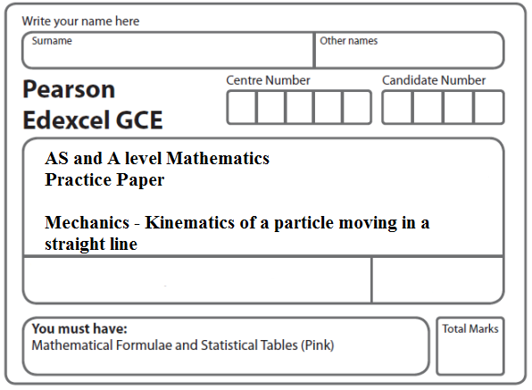
Instructions
- Use black ink or ball-point pen.
- If pencil is used for diagrams/sketches/graphs it must be dark (HB or B).
- Fill in the boxes at the top of this page with your name, centre number and candidate number.
- Answer all the questions and ensure that your answers to parts of questions are clearly labelled.
- Answer the questions in the spaces provided – there may be more space than you need.
- You should show sufficient working to make your methods clear. Answers without working may not gain full credit.
- Inexact answers should be given to three significant figures unless otherwise stated.
Information
- A booklet ‘Mathematical Formulae and Statistical Tables’ is provided.
- There are 8 questions in this question paper. The total mark for this paper is 98.
- The marks for each question are shown in brackets – use this as a guide as to how much time to spend on each question.
Advice
• Read each question carefully before you start to answer it.
• Try to answer every question.
• Check your answers if you have time at the end.
• If you change your mind about an answer, cross it out and put your new answer and any working underneath.
1.

Figure 4

The velocity-time graph in Figure 4 represents the journey of a train P travelling along a straight horizontal track between two stations which are 1.5 km apart. The train P leaves the first station, accelerating uniformly from rest for 300 m until it reaches a speed of 30 m s^{–1}. The train then maintains this speed for T seconds before decelerating uniformly at 1.25 m s^{–2}, coming to rest at the next station.

(a) Find the acceleration of P during the first 300 m of its journey.
(2)
(b) Find the value of T.
(5)

A second train Q completes the same journey in the same total time. The train leaves the first station, accelerating uniformly from rest until it reaches a speed of V m s^{–1} and then immediately decelerates uniformly until it comes to rest at the next station.

(c) Sketch on the diagram above, a velocity-time graph which represents the journey of train Q.
(2)
(d) Find the value of V.
(6)

(Total 15 marks)
___________________________________________________________________________
2. A stone is projected vertically upwards from a point A with speed u m s^{–1}. After projection the stone moves freely under gravity until it returns to A. The time between the instant that the stone is projected and the instant that it returns to A is 3 seconds.

Modelling the stone as a particle,

(a) show that u = 17,
(3)
(b) find the greatest height above A reached by the stone,
(2)
(c) find the length of time for which the stone is at least 6 m above A.
(6)
Total 11 marks)
___________________________________________________________________________

3. A car accelerates uniformly from rest for 20 seconds. It moves at constant speed v m s⁻¹ for the next 40 seconds and then decelerates uniformly for 10 seconds until it comes to rest.

(a) For the motion of the car, sketch

(i) a speed-time graph,

(ii) an acceleration-time graph.
(6)

Given that the total distance moved by the car is 880 m,

(b) find the value of v.
(4)
(Total 10 marks)
___________________________________________________________________________
4. A cyclist is moving along a straight horizontal road and passes a point A. Five seconds
later, at the instant when she is moving with speed 10 m s^{–1}, she passes the point B. She
moves with constant acceleration from A to B.
Given that AB = 40 m, find
(a) the acceleration of the cyclist as she moves from A to B,
(4)
(b) the time it takes her to travel from A to the midpoint of AB.
(5)
(Total 9 marks)
___________________________________________________________________________

5. A car moves along a straight horizontal road from a point A to a point B, where AB = 885 m. The car accelerates from rest at A to a speed of 15 m s^{–1} at a constant rate a m s^{–2}.

The time for which the car accelerates is T seconds. The car maintains the speed of 15 m s^{–1} for T seconds. The car then decelerates at a constant rate of 2.5 m s^{–2} stopping at B.

(a) Find the time for which the car decelerates.
(2)
(b) Sketch a speed-time graph for the motion of the car.
(2)
(c) Find the value of T.
(4)
(d) Find the value of a.
(2)
(e) Sketch an acceleration-time graph for the motion of the car.
(3)
(Total 13 marks)
___________________________________________________________________________

6. A train travels along a straight horizontal track between two stations, A and B. The train starts from rest at A and moves with constant acceleration 0.5 m s^{–2} until it reaches a speed of V m s^{–1}, (V < 50). The train then travels at this constant speed before it moves with constant deceleration 0.25 m s^{–2} until it comes to rest at B.

(a) Sketch a speed-time graph for the motion of the train between the two stations A and B.
(2)

The total time for the journey from A to B is 5 minutes.

(b) Find, in terms of V, the length of time, in seconds, for which the train is

(i) accelerating,

(ii) decelerating,

(iii) moving with constant speed.
(5)

Given that the distance between the two stations A and B is 6.3 km,

(c) find the value of V.
(6)
(Total 13 marks)
___________________________________________________________________________
7. A particle P is projected vertically upwards from a point A with speed u m s^{–1}. The point A is 17.5 m above horizontal ground. The particle P moves freely under gravity until it reaches the ground with speed 28 m s^{–1}.

(a) Show that u = 21.
(3)

At time t seconds after projection, P is 19 m above A.

(b) Find the possible values of t.
(5)

The ground is soft and, after P reaches the ground, P sinks vertically downwards into the ground before coming to rest. The mass of P is 4 kg and the ground is assumed to exert a constant resistive force of magnitude 5000 N on P.

(c) Find the vertical distance that P sinks into the ground before coming to rest.
(4)
(Total 12 marks)
___________________________________________________________________________

8.

Figure 3

Two particles P and Q, of mass 0.3 kg and 0.5 kg respectively, are joined by a light horizontal rod. The system of the particles and the rod is at rest on a horizontal plane.

At time t = 0, a constant force F of magnitude 4 N is applied to Q in the direction PQ, as shown in Figure 3. The system moves under the action of this force until t = 6 s. During the motion, the resistance to the motion of P has constant magnitude 1 N and the resistance to the motion of Q has constant magnitude 2 N.

Find

(a) the acceleration of the particles as the system moves under the action of F,
(3)
(b) the speed of the particles at t = 6 s,
(2)
(c) the tension in the rod as the system moves under the action of F.
(3)

At t = 6 s, F is removed and the system decelerates to rest. The resistances to motion are unchanged. Find

(d) the distance moved by P as the system decelerates,
(4)
(e) the thrust in the rod as the system decelerates.
(3)
(Total 15 marks)

TOTAL FOR PAPER: 98 MARKS

