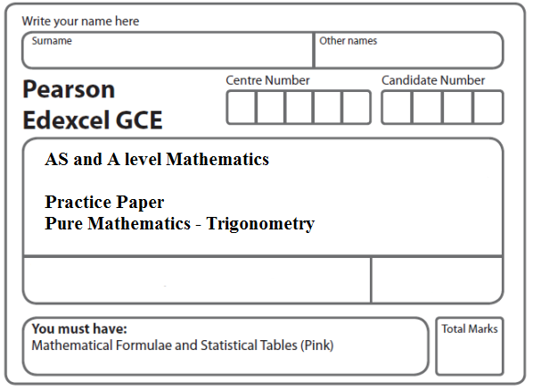
Instructions
- Use black ink or ball-point pen.
- If pencil is used for diagrams/sketches/graphs it must be dark (HB or B).
- Fill in the boxes at the top of this page with your name, centre number and candidate number.
- Answer all the questions and ensure that your answers to parts of questions are clearly labelled.
- Answer the questions in the spaces provided – there may be more space than you need.
- You should show sufficient working to make your methods clear. Answers without working may not gain full credit.
- Inexact answers should be given to three significant figures unless otherwise stated.
Information
- A booklet ‘Mathematical Formulae and Statistical Tables’ is provided.
- There are 6 questions in this question paper. The total mark for this paper is 49.
- The marks for each question are shown in brackets – use this as a guide as to how much time to spend on each question.
Advice
• Read each question carefully before you start to answer it.
• Try to answer every question.
• Check your answers if you have time at the end.
• If you change your mind about an answer, cross it out and put your new answer and any working underneath.
1. Solve, for 0 ≤ x < 180°
cos (3x − 10°) = −0.4
giving your answers to 1 decimal place. You should show each step in your working.
(Total 7 marks)
___________________________________________________________________________

2. (a) Show that the equation
cos² x = 8sin² x – 6sin x
can be written in the form
(3sin x – 1)² = 2
(3)
(b) Hence solve, for 0 ⩽ x < 360°,
cos²x = 8sin²x – 6sin x
giving your answers to 2 decimal places.
(5)
(Total 8 marks)
___________________________________________________________________________

3. (a) Show that the equation
tan 2x = 5 sin 2x
can be written in the form
(1 – 5 cos 2x) sin 2x = 0
(2)
(b) Hence solve, for 0 ≤ x ≤ 180°
tan 2x = 5 sin 2x
giving your answers to 1 decimal place where appropriate.
You must show clearly how you obtained your answers.
(5)
(Total 7 marks)
___________________________________________________________________________

4. (a) Show that the equation
3 sin² x + 7 sin x = cos² x − 4
can be written in the form
4 sin² x + 7 sin x + 3 = 0
(2)
(b) Hence solve, for 0 ≤ x < 360°
3 sin² x + 7 sin x = cos² x − 4
giving your answers to 1 decimal place where appropriate.
(5)
(Total 7 marks)
___________________________________________________________________________

5. (i) Solve, for 0 ≤ θ < 360°, the equation 9 sin (θ + 60°) = 4, giving your answers to 1 decimal place. You must show each step of your working.
(4)
(ii) Solve, for –π ≤ x < π, the equation 2 tan x – 3 sin x = 0, giving your answers to 2 decimal places where appropriate.

[Solutions based entirely on graphical or numerical methods are not acceptable.]
(5)
(Total 11 marks)
___________________________________________________________________________

6. (i) Solve, for –180° ≤ x < 180°,
tan(x – 40°) = 1.5,
giving your answers to 1 decimal place.
(3)
(ii) (a) Show that the equation
sin θ tan θ = 3 co sθ + 2
can be written in the form
4 cos²θ + 2 cos θ – 1 = 0.
(3)
(b) Hence solve, for 0 ≤ θ < 360°,
sin θ tan θ = 3 cos θ + 2,
showing each stage of your working.
(5)
(Total 11 marks)

TOTAL FOR PAPER: 49 MARKS

