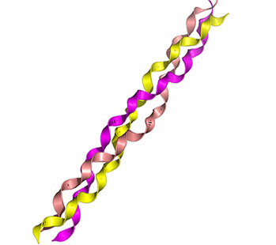Collagen

**Questions**

*Where would you find collagen in the body? What is its main function?*

*What properties must collagen have to do these jobs effectively?*

*Describe the structure shown in the picture above. What does it show? Include as much detail as possible – add labels if you like.*