Haemoglobin

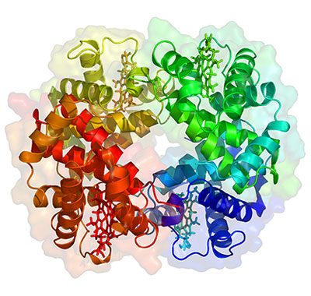

Haemoglobin is a protein.

*What is haemoglobin’s function? (3)*

*What properties must it have in order to carry out this function? (4)*

*Identify and label the following structures on the picture above. (3)*

* Haem group
* Alpha sub-unit
* Beta sub-unit

*Use this image to explain the term “quaternary structure”. (2)*

*Haemoglobin is a globular, soluble protein. How will the R groups of the amino acids be arranged in haemoglobin? Explain your answer. (2)*

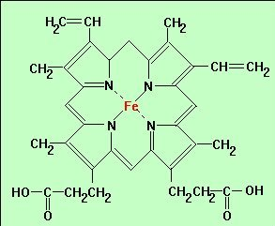Haemoglobin (*continued*)

*What part of the haemoglobin molecule is shown below? (1)*

*What is the name given to non-protein groups that form an essential part of the protein? (1)*

*What is the essential function of this non-protein part of haemoglobin? (1)*

*What’s the point of all the protein parts of haemoglobin, then? (2)*

***References***

***Pages 64-66 OCR textbook***

***page 103 Big Green Textbook***