Extract A: Call for extra bank holiday to be made permanent

Business leaders have urged the prime minister to make this year's extra bank holiday marking the Queen's Platinum Jubilee permanent. In an open letter, the CBI, UK Hospitality and a host of well-known brands said a "thank holiday" would honour the monarch and public service.

They argued that the new holiday would provide an economic boost after Covid.

Signatories of the letter said that making the holiday permanent would "provide a moment every year for individuals and communities to come together, to thank those who have contributed in ways big and small to making our country a better place to live".

They included the bosses of Siemens and Punch Pubs and the chairman of the Campaign for Real Ale, as well as investor and entrepreneur Deborah Meaden, who is leading the campaign.
The Dragons' Den star said the move would provide "the country with a social and economic stimulus we need after a difficult few years".

Ministers are concerned that an extra bank holiday would come at a significant cost to the UK economy. Government modelling would put the cost of an extra bank holiday at £1.36bn however, PwC says, taking into account the impact on business of closures, disruption to production schedules, and premium payments to staff working on the bank holiday they estimate the cost to be about £831m.

PwC points out that social positives might have been missed out, and that sectors such as retail and hospitality, which were badly affected during the pandemic, would benefit from an uplift in demand.

The findings also suggest that any knock-on costs would be lower if the new bank holiday were scheduled for a Friday because fewer hours are worked that day on average.

England and Wales currently have eight bank holidays annually, in comparison with the European Union average of 11.
Adapted from: https://www.bbc.co.uk/news/business-61219129 (26/04/22)

Extract B: UK credit card borrowing soars to highest monthly level since 2004

- Credit card borrowing in the UK soared in November to its highest monthly level since 2004 amid mounting pressure on households from the cost of living crisis.

The latest snapshot from the Bank of England showed individuals borrowed an additional £1.5bn in all forms of consumer credit, of which £1.2bn was on credit cards, as concerns mounted over the impact of high inflation on struggling households.

Coinciding with the beginning of the Christmas shopping period and rising energy bills, the jump from October’s £700m in unsecured borrowing prompted concerns among anti-poverty charities that some people were turning to expensive forms of credit to make ends meet.
Heidi Chow, executive director at the campaign group Debt Justice, said: “Booming credit card borrowing at a time of falling incomes and rising living costs is another warning light on the dashboard that people are becoming more dependent on expensive credit to make ends meet.
increasingly be turning to credit to meet essential spending into the new year and beyond.”
The Bank’s figures showed a sharp fall in mortgage approvals, reflecting the increase in borrowing costs after successive rate increases from the central bank over the past year, as well as the ongoing consequences of Liz Truss’s ill-fated mini budget.
Mortgage approvals to fund house purchases fell to 46,100 in November, down from 57,900 in the previous month and more than 100,000 in November 2020, when a stamp duty holiday was in place.
The total stock of consumer credit remained as much as £18.4bn below a peak seen in January 2020, and was worth only about 13.5% of households’ annual income – well down on a pre-Covid peak of 16%.
Adapted from: https://www.theguardian.com/business/2023/jan/04/uk-credit-card-borrowing-soars-to-highest-monthly-level-since-2004 (04/01/23)

Figure 1: House prices expected to fall

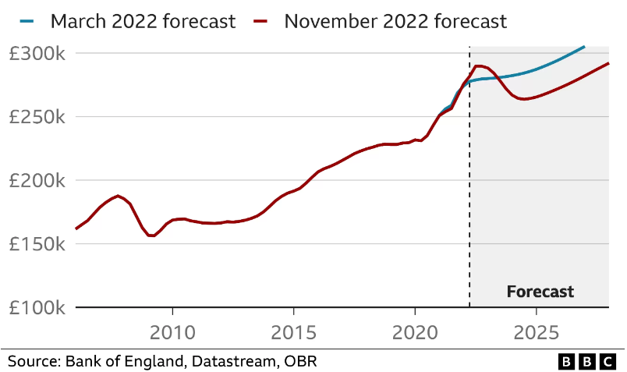

Source: https://www.bbc.co.uk/news/business-63676119 (18/11/22)

Questions
- With reference to the figure 1, explain the possible impact of falling house prices on consumption
- With reference to extract B, assess whether the government should attempt to increase AD by making credit more available to consumers
- With reference to extract A, assess whether introducing a new bank holiday would be effective in shifting out the UK’s LRAS
- With reference to the information provided, assess whether changes to wealth or changes to inflation are likely to have a bigger impact on the UK’s real output

