Padlet based questions:

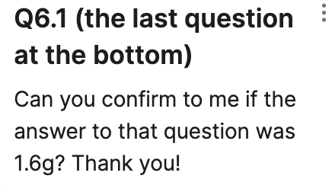 | - e) 2Mg : 2O or 1:1 ratio 2.4g of Mg = 0.1moles so we need 0.1 moles of oxygen (O2): 0.1 x 32 = 3.2g
Youtube channel question: good resources | https://www.youtube.com/watch?v=qZ3INba16v0&list=PLkocNW0BSuEFvnpnhj8fKN-KFUOlnKiT0&ab_channel=SnapRevise  MaChemGuy  https://www.youtube.com/channel/UCps4gUjfZsu6-b-7mwK41lg
Revision practice | https://www.amazon.co.uk/Level-Chemistry-Essential-Maths-Skills/dp/1782944729/ref=asc_df_1782944729/?tag=googshopuk-21&linkCode=df0&hvadid=310873701019&hvpos=&hvnetw=g&hvrand=4234580778184671287&hvpone=&hvptwo=&hvqmt=&hvdev=c&hvdvcmdl=&hvlocint=&hvlocphy=9045908&hvtargid=pla-564973654958&psc=1&th=1&psc=1  any cgp guide for your board  Physics and maths tutor revision materials
Bridging gap | https://www.cgpbooks.co.uk/secondary-books/as-and-a-level/science/chemistry/cbr72-head-start-to-a-level-chemistry-(with-online
Practice questions and where to look for them | Physics and maths tutor

