Metabolic Enzymes and PKU

The diagram shows some of the stages involved in the breakdown of phenylalanine by the liver.

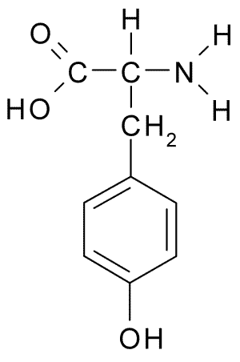
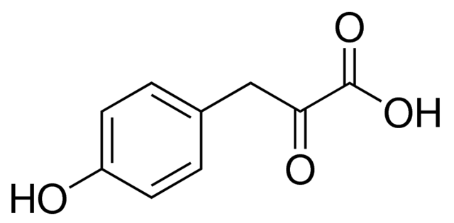
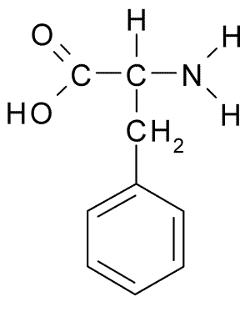

ACoA

phenylalanine tyrosine hydroxyphenylpyruvate

Phenylalanine is converted to tyrosine by the enzyme phenylalanine hydroxylase (PAH).
A heritable defect in this enzyme leads to accumulation of phenylalanine, and its keto acid (phenylketone) in the body fluids.

The presence of high levels of phenylketone in the urine gives the disease, phenylketonuria (PKU), its name.

Through an unknown mechanism, either phenylalanine or phenylketone leads to progressive brain damage.

A less serious symptom of PKU is that sufferers appear pale, as they have less melanin in their skin.

Melanin is a polymer of tyrosine produced by the enzyme tyrosinase. This enzyme is competitively inhibited by phenylalanine. It is also more active at lower temperatures.

PKU is a recessive autosomal condition that affects 1 in 20,000 newborns.

Questions

- Use the diagram to explain the difference between essential and non-essential amino acids.
- Use the diagrams to outline the R group of Phenylalanine.
- Describe what phenylalanine hydroxylase does to phenylalanine.
- How will phenylalanine differ from tyrosine in chemical properties? Explain your answer.
- Suggest why phenylalanine is a competitive inhibitor of tyrosinase.
- Although tyrosine is classified as a non-essential amino acid, it becomes essential in people with PKU. Explain why.
- What is the name of the type of reaction that converts tyrosine to hydroxyphenylpyruvate? What is the other product of this reaction?
- Use the diagram to explain how proteins can be a source of ATP for cells.
- It is very easy to test for PKU, and all babies in the UK are tested using a drop of blood (the heel prick test) taken a few days after birth. Suggest what the PKU test looks for in the blood, and explain why the babies are tested a few days after birth, and not immediately.
- PKU is easily controlled so that no problems arise. How would you control PKU?
- PKU is a very serious condition if untreated – why has it not been eliminated by natural selection?
- What additional supplement might PKU sufferers have to take, and what problems might they face if they failed to take it?
- Himalayan rabbits have white bodies and black ears, feet and tails. Why?
- Assuming a UK population of 80,000,000, how many will be carriers?

