[UK faces vet shortage due to Brexit export rules amid surge in pet ownership during Covid lockdown (inews.co.uk)](https://inews.co.uk/news/uk-vet-shortage-brexit-export-rules-pet-ownership-covid-lockdown-1129345)

**UK faces vet shortage due to Brexit export rules amid surge in pet ownership during Covid lockdown**

The number of EU vets arriving to work in Britain – which has traditionally plugged the shortfall in UK-trained vets – has dropped dramatically after Brexit

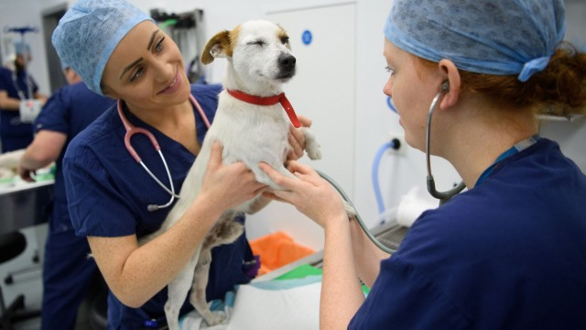The pandemic has sparked a surge in pet ownership in the past 18 months but the number of EU vets arriving to work in Britain after Brexit has dropped dramatically (Photo: Getty/Leon Neal)

[author avatar image](https://inews.co.uk/author/madeleine-cuff)

**By**[**Madeleine Cuff**](https://inews.co.uk/author/madeleine-cuff)

Environment Correspondent

July 30, 2021 5:48 pm

The UK is facing a critical shortage of vets that is set to intensify in the coming months as new EU export rules kick in, industry insiders have warned.

The pandemic has sparked [a surge in pet ownership in the past 18 months](https://inews.co.uk/inews-lifestyle/wellbeing/boom-puppy-sales-pandemic-covid-19-coronavirus-abandoned-dogs-charity-580688?ico=in-line_link), while Brexit rules demand more vets to sign export health certificates to move animals or meat between the UK and the EU.

But the number of EU vets arriving to work in Britain – which has traditionally plugged the shortfall in UK-trained vets – has dropped dramatically.

The number of new EU vets being registered to work in the UK is down to as little as 20 individuals per month, according to a private briefing shown to ministers this month. In previous years this figure would have been closer to 80 or 100.

The shortfall could affect the food supply chain as well as [pet owners](https://inews.co.uk/inews-lifestyle/wellbeing/coronavirus-dogs-pets-advice-psychology-lockdown-preparations-421304?ico=in-line_link).

Charles Hartwell is the chief executive of Eville & Jones, which supplies veterinary services to abattoirs. He said staffing shortages are partly driven by new rules set by the Royal College of Veterinary Surgeons (RCVS), which requires vets to formally meet high standards of English.

“Most European vets, although they meet all the technical standards and before 1 January 2021 could have come and worked here without any problem, they don’t have that level of English,” he said.

“Therefore, what we are seeing is where we need a load more vets to come into the system, the number of vets coming in from the European Union has collapsed.”

Mr Hartwell said his firm is short of 30 vets, out of a total workforce of 300. A temporary exemption to the English language requirement, valid until June 2022, has meant that the company has been able to cope.

But he warned that the new rule will have a [severe effect on the wider sector](https://inews.co.uk/news/uk/staff-fostering-pets-animal-shelters-coronavirus-social-distancing-measures-418644?ico=in-line_link), risking wage inflation and price rises. This will escalate after 1 October, when all exports of animal-based food products will require inspection and certification from a vet.

“It’s a challenge for the whole profession,” Mr Hartwell said.

Last month, a letter sent to vet practices across the country by out-of-hours provider Vets Now warned it was becoming “increasingly challenging to staff our clinics”. It listed the rise in pet ownership during the pandemic and an industry shortage of vets as the primary causes.

“We are doing all we can to ensure continuity of service in our clinics, but on occasion, when we do not have adequate staff to operate our service safely, we have made the difficult decision to close one of our clinics and divert the staff and the caseload to another nearby clinic,” the letter read.

A spokesman for the RCVS said the language requirements for vets coming from the EU to the UK were to ensure that foreign vets are “appropriately trained” to practise in the UK. He said training and support is on hand to support vets who are moving to the UK.

“Ultimately, we need to boost the numbers of UK veterinary graduates so that we are less reliant on overseas-qualified vets, which will require additional funding and support from Government,” he added.

Extension:

[Brexit set to cause shortage of animal medicines in Northern Ireland | The Independent](https://www.independent.co.uk/news/uk/politics/brexit-animals-veterinary-medicine-northern-ireland-b2131464.html)