‘My hair is not my character’: Teens ask San Antonio council to ban natural hair discrimination

[Vincent T. Davis](https://www.expressnews.com/author/vincent-davis/), Staff writer

March 2, 2023Updated: March 2, 2023 3:23 p.m.

[Comments](https://www.expressnews.com/politics/articleComments/hair-discrimination-teens-san-antonio-17815860.php)

7

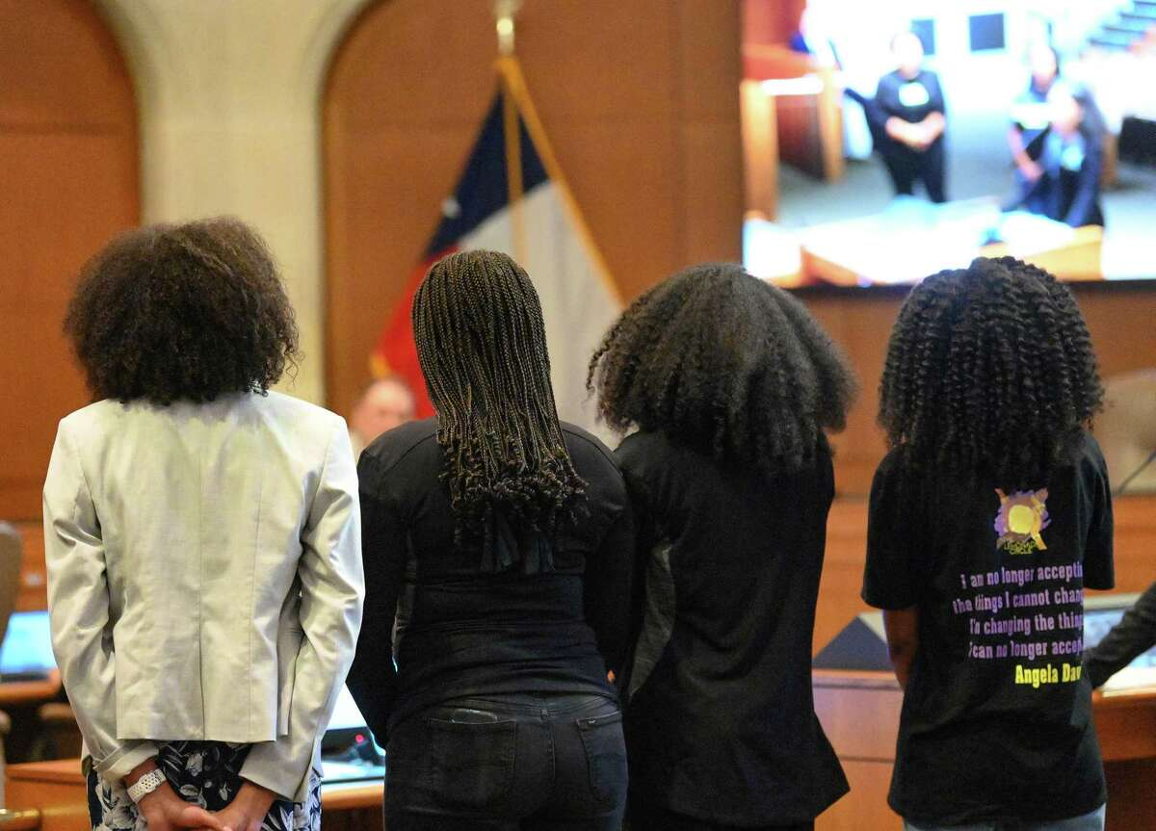1of7

Teen members of The Lemonade Circle speak in City Council Chambers on Wednesday, March 1, 2023, asking for the passage of the CROWN Act, which calls for banning hair discrimination based on race, culture, ethnicity, or national origin.

Billy Calzada / Staff photographer[Show More](https://www.expressnews.com/politics/article/hair-discrimination-teens-san-antonio-17815860.php)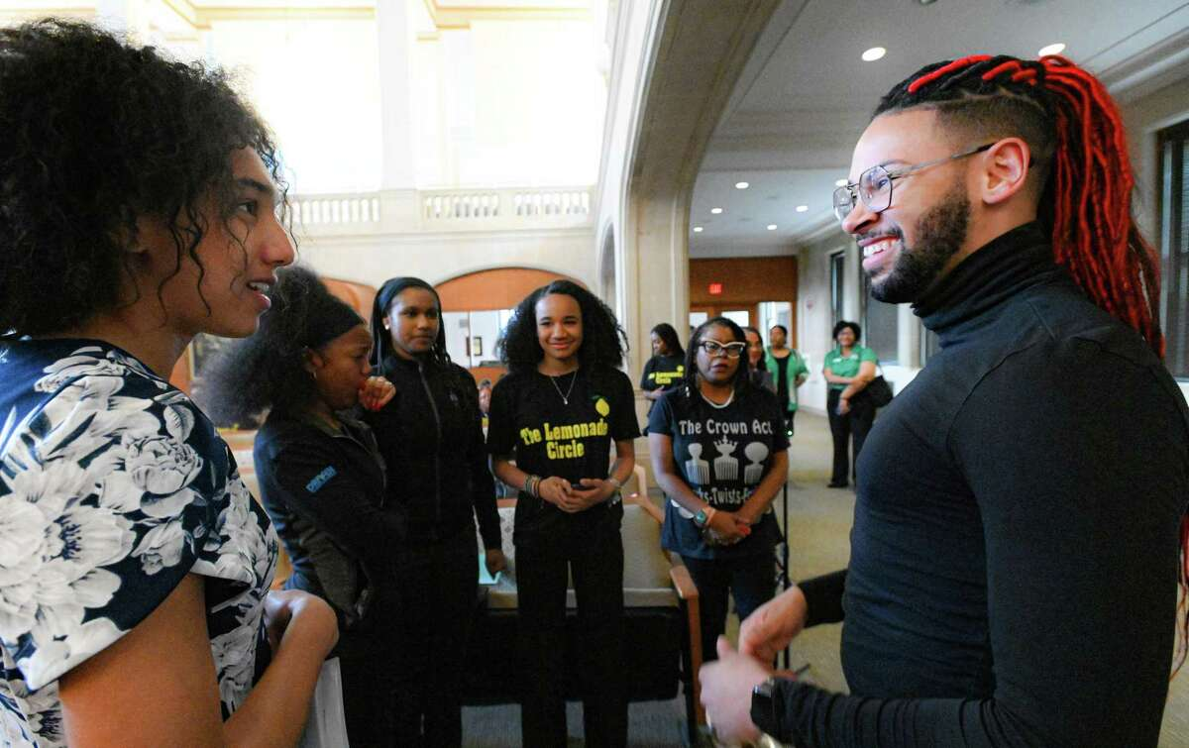

SAN ANTONIO — Elementary school classmates used to tease 16-year-old Janabou Diallo about wearing braids.

Teachers criticized her hair in the hallways.

Long, full hair framing her face, Janabou was one of six Black teens who asked City Council this week to [do something about an issue](https://www.thecrownact.com/)they’ve experienced they’ve long experienced — hair discrimination.

She said her curls didn’t mean she was sassy or disrespectful or uncivil.

“I believe people need to know that my character lies far deeper than the surface,” Janabou said. “My hair is not my character.”

The Judson Early College Academy sophomore joined the San Antonio Chapter of The Links and Girl Up on Wednesday evening as part of a national movement to pass the CROWN Act (Creating a Respectful and Open World for Natural Hair).

It would ban hair discrimination based on race, culture, ethnicity or national origin. The proposal would protect hair texture and styles such as braids, knots, locks and twists in public schools and workplaces.

In June 2022, Austin became the first city in Texas to approve the act that is a law in 20 states, 45 cities and the U.S. Virgin Islands.

District 2 Councilman Jalen McKee-Rodriguez has filed a proposal for the council to consider. The councilman collaborated with The Lemonade Circle and said the teens’ leadership is an example of young people working to create a better future.

“We are happy to support this effort to make our city safer and more accessible to all San Antonians, especially Black, Indigenous and people of color who face discrimination that limits their economic potential,” McKee-Rodriguez said in a statement.

Janabou’s voice echoed through the chamber during the public comment session, where more than 50 supporters applauded her testimonial.

She led the appeal, followed by Neveah Sage, Victorya Hardaway, Amaya Simmons, Daniya Vidal and Iman Zakaria, all members of The Lemonade Circle, a nonprofit founded by Brandi Coleman to empower and mentor girls of color from the fifth through 12th grades.

The CROWN Coalition, Dove and State Senator Holly J. Mitchell of California created the proposal in 2019. A Dove study reported that Black women are 1.5 times more likely to be sent home from work because of their hairstyle.

Davette Mabrie, founder of the San Antonio Natural Hair Society, said she’s waited years for the proposal. A braid artist for more than 40 years, Mabrie owns Davette’s Braids and Locs on the Northeast side.

She has spoken out about braided hair as an art to mainstream media across the nation. In 2017, CNN and the New York Times interviewed her about the Army dropping its ban on dreadlocks. Active duty military and veterans are many of her clients.

“Please let this bill pass,” Mabrie said. “It’s very important to our community and the Afro-Latino community.”

As the teens spoke, several supporters held up signs that read, “Help us protect our CROWN Act.”

Daniya Vidal, 16, spoke of a woman who had to cut her locs to keep her job and students disciplined because they wore braids.

“The history of my hair shall not be forgotten,” she said. “It has roots more profound and richer than the ones coming from my scalp.”

Iman, 17, said criticism in middle school prompted her to have her hair straightened because she felt it created a ‘barricade’ around her.

The teen said she grew thicker skin and learned to love her “precious locks.”

Victorya, 16, shared experiences of people who had disdain for her hairstyle. People asked if her hair was real and if they could touch it.

The CROWN act, Victorya said, would help people better understand the issue.

Nevaeh, 15, said African American women should not have to straighten their hair to conform to workplace rules.

“This is crucial to me because this would affect others who look like me and future generations,” Nevaeh said. “We are more than the curls on our head, but they are still important to us. They represent and express our culture and identity more effectively than anything else.”

Coleman expressed her pride to the members for their commitment. She said they are dedicated to ensuring the act is not only passed in San Antonio, but every city and school district in Texas.

Amaya, 16, said hair bias affects not only women and girls but men and boys.

She dreams that one day she will walk into a job interview, her Afro big as a cloud, confident that her hair will not keep her from getting the job.

[](https://www.expressnews.com/author/vincent-davis/)

Written By

[Vincent T. Davis](https://www.expressnews.com/author/vincent-davis/)

Reach Vincent T. on

Vincent T. Davis started at the San Antonio Express-News in 1999 as a part-time City Desk Editorial Assistant working nights and weekends while attending San Antonio College and working on the staff of the campus newspaper, The Ranger. He completed a 3-month fellowship from the Freedom Forum Diversity Institute at Vanderbilt University in 2003 and earned his bachelors degree in communication design from Texas State University in 2006.

Statistics: [Black Hair Is Professional: Why Dove Is Fighting Race-Based Hair Discrimination | LBBOnline](https://www.lbbonline.com/news/black-hair-is-professional-why-dove-is-fighting-race-based-hair-discrimination)

Extra: [Banning natural hair discrimination in Michigan gets renewed push from Black lawmakers - mlive.com](https://www.mlive.com/politics/2023/02/banning-natural-hair-discrimination-in-michigan-gets-renewed-push-from-black-lawmakers.html)