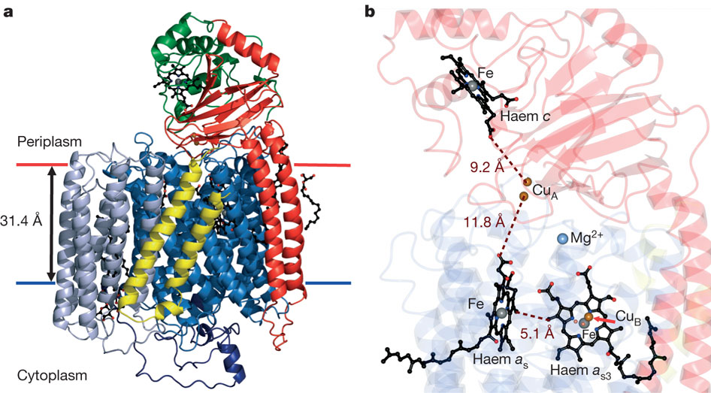**Thinking about tertiary structure in enzymes**

*Fig. 1*

Fig. 1 shows an enzyme called cytochrome oxidase. It is a vitally important enzyme in the process of cellular respiration.

The pictures below represent two cytochrome oxidase molecules taken from two different types of **extremophile** bacteria.

*Thermophilus aquaticus Psychrophile antarcticus*

*Thermophilus aquaticus* is a heat loving bacterium that thrives in the hot springs of Yellowstone Park – it can survive in pressurised steam at temperatures of over 100’C.

*Psychrophile antarcticus* lives in ice in Antarctica. It grows and reproduces in temperatures only just above freezing.

**Question**

*Compare and contrast the tertiary structure of cytochrome oxidase in the two types of bacteria. Try to explain any similarities or differences using your knowledge and understanding of how enzymes work.*